import numpy as np  
import pandas as pd  
import seaborn as sns  
import matplotlib.pyplot as plt  
import matplotlib.patches as mpatches  
from plotly.subplots import make_subplots  
import plotly.graph_objs as go  
import plotly.express as px  
from sklearn.cluster import KMeans  
from sklearn.preprocessing import StandardScaler  
from sklearn.preprocessing import MinMaxScaler

from sklearn.model_selection import train_test_split  
from sklearn.preprocessing import MinMaxScaler  
from sklearn.ensemble import BaggingClassifier  
from sklearn.tree import DecisionTreeClassifier  
from sklearn.ensemble import RandomForestClassifier, ExtraTreesClassifier, AdaBoostClassifier, GradientBoostingClassifier, VotingClassifier, StackingClassifier  
from xgboost import XGBClassifier, XGBRegressor  
from sklearn.metrics import accuracy_score, classification_report, confusion_matrix, roc_auc_score, f1_score, ConfusionMatrixDisplay, r2_score,precision_score  
from sklearn.metrics import mean_squared_error  
from sklearn.linear_model import LogisticRegression  
from sklearn.tree import DecisionTreeClassifier   
from sklearn.ensemble import RandomForestClassifier  
from sklearn.ensemble import GradientBoostingClassifier  
from xgboost import XGBClassifier  
from sklearn.ensemble import ExtraTreesClassifier  
from sklearn.ensemble import BaggingClassifier  
from sklearn.ensemble import AdaBoostClassifier  
from sklearn.linear_model import RidgeClassifier  
from sklearn.svm import LinearSVC  
from sklearn.preprocessing import LabelBinarizer  
from sklearn.model_selection import KFold  
from sklearn.model_selection import cross_val_score

# Dữ liệu

df = pd.read_excel('Insurance.xlsx')  
df.head()

Customer State Customer Lifetime Value Response Coverage Education   
0 BU79786 Washington 2763.519279 No Basic Bachelor \  
1 QZ44356 Arizona 6979.535903 No Extended Bachelor   
2 AI49188 Nevada 12887.431650 No Premium Bachelor   
3 WW63253 California 7645.861827 No Basic Bachelor   
4 HB64268 Washington 2813.692575 No Basic Bachelor   
  
 Effective To Date EmploymentStatus Gender Income ... Number of Policies   
0 2019-02-24 Employed F 56274 ... 1 \  
1 2019-01-31 Unemployed F 0 ... 8   
2 2019-02-19 Employed F 48767 ... 2   
3 2019-01-20 Unemployed M 0 ... 7   
4 2019-03-02 Employed M 43836 ... 1   
  
 Policy Type Policy Renew Offer Type Sales Channel   
0 Corporate Auto Corporate L3 Offer1 Agent \  
1 Personal Auto Personal L3 Offer3 Agent   
2 Personal Auto Personal L3 Offer1 Agent   
3 Corporate Auto Corporate L2 Offer1 Call Center   
4 Personal Auto Personal L1 Offer1 Agent   
  
 Total Claim Amount Vehicle Class Vehicle Size Age Months Since Driving   
0 384.811147 Two-Door Car Medsize 41 236   
1 1131.464935 Four-Door Car Medsize 39 5   
2 566.472247 Two-Door Car Medsize 54 23   
3 529.881344 SUV Medsize 23 12   
4 138.130879 Four-Door Car Medsize 70 643   
  
[5 rows x 26 columns]

## Tiền xử lý

### Chọn các cột đặc trưng

df_model=df[['Customer','Vehicle Class','Coverage','Marital Status','Location Code','Months Since Driving',  
 'Age','EmploymentStatus','Monthly Premium Auto','Months Since Last Claim','State']]  
df_model

Customer Vehicle Class Coverage Marital Status Location Code   
0 BU79786 Two-Door Car Basic Married Suburban \  
1 QZ44356 Four-Door Car Extended Single Suburban   
2 AI49188 Two-Door Car Premium Married Suburban   
3 WW63253 SUV Basic Married Suburban   
4 HB64268 Four-Door Car Basic Single Rural   
... ... ... ... ... ...   
9129 LA72316 Four-Door Car Basic Married Urban   
9130 PK87824 Four-Door Car Extended Divorced Suburban   
9131 TD14365 Four-Door Car Extended Single Suburban   
9132 UP19263 Four-Door Car Extended Married Suburban   
9133 Y167826 Two-Door Car Extended Single Suburban   
  
 Months Since Driving Age EmploymentStatus Monthly Premium Auto   
0 236 41 Employed 69 \  
1 5 39 Unemployed 94   
2 23 54 Employed 108   
3 12 23 Unemployed 106   
4 643 70 Employed 73   
... ... ... ... ...   
9129 263 57 Employed 73   
9130 262 49 Employed 79   
9131 162 46 Unemployed 85   
9132 253 65 Employed 96   
9133 374 49 Unemployed 77   
  
 Months Since Last Claim State   
0 32 Washington   
1 13 Arizona   
2 18 Nevada   
3 18 California   
4 12 Washington   
... ... ...   
9129 18 California   
9130 14 California   
9131 9 California   
9132 34 California   
9133 3 California   
  
[9134 rows x 11 columns]

### Kiểm tra giá trị null

df_model.isnull().sum()

Customer 0  
Vehicle Class 0  
Coverage 0  
Marital Status 0  
Location Code 0  
Months Since Driving 0  
Age 0  
EmploymentStatus 0  
Monthly Premium Auto 0  
Months Since Last Claim 0  
State 0  
dtype: int64

### Kiểm tra giá trị trùng lặp

df_model.duplicated().sum()

0

### Kiểm tra giá trị ngoại lai

fig, axes = plt.subplots(nrows=4, ncols=1, figsize=(15, 15))  
df_model[["Monthly Premium Auto"]].boxplot(ax=axes[0], vert=False)  
df_model[["Months Since Last Claim"]].boxplot(ax=axes[1], vert=False)  
df_model[["Age"]].boxplot(ax=axes[2], vert=False)  
df_model[["Months Since Driving"]].boxplot(ax=axes[3], vert=False)

<Axes: >

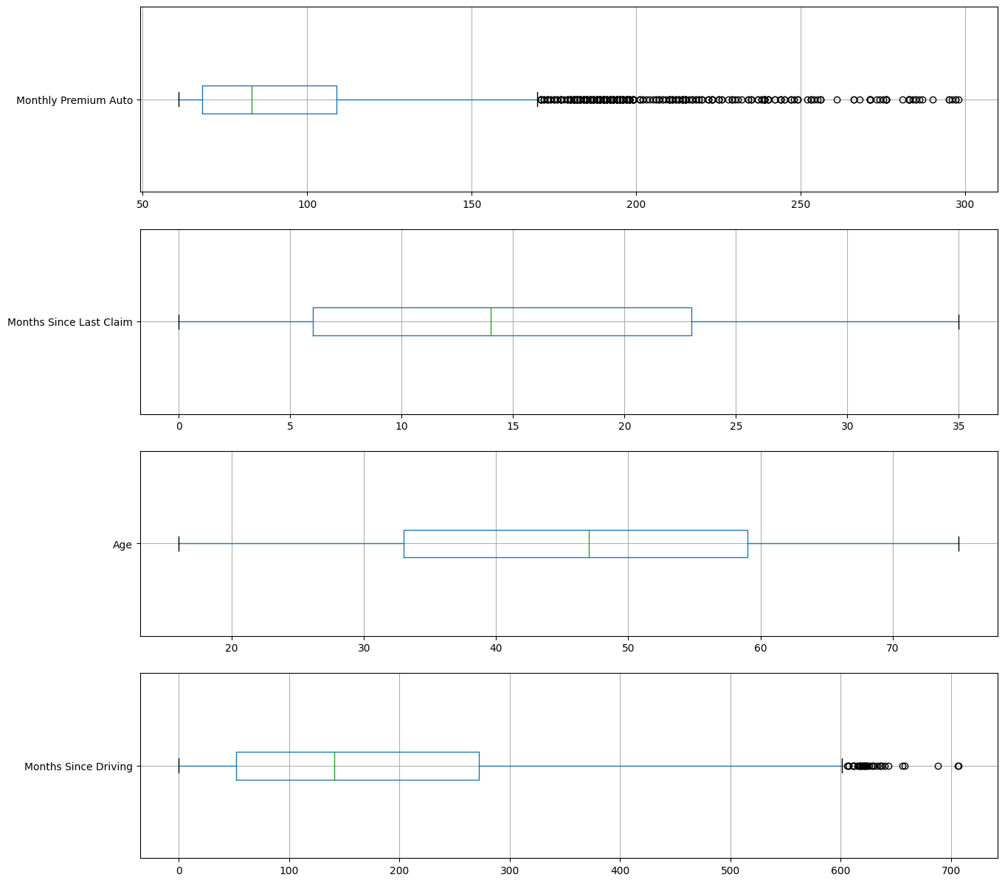

export_csv = df_model.to_excel (r'Insurance_pricing.xlsx', index = None, header=True)

basic=df_model[df_model['Coverage']=='Basic']  
extended=df_model[df_model['Coverage']=='Extended']  
premium=df_model[df_model['Coverage']=='Premium']  
df_model

Customer Vehicle Class Coverage Marital Status Location Code   
0 BU79786 Two-Door Car Basic Married Suburban \  
1 QZ44356 Four-Door Car Extended Single Suburban   
2 AI49188 Two-Door Car Premium Married Suburban   
3 WW63253 SUV Basic Married Suburban   
4 HB64268 Four-Door Car Basic Single Rural   
... ... ... ... ... ...   
9129 LA72316 Four-Door Car Basic Married Urban   
9130 PK87824 Four-Door Car Extended Divorced Suburban   
9131 TD14365 Four-Door Car Extended Single Suburban   
9132 UP19263 Four-Door Car Extended Married Suburban   
9133 Y167826 Two-Door Car Extended Single Suburban   
  
 Months Since Driving Age EmploymentStatus Monthly Premium Auto   
0 236 41 Employed 69 \  
1 5 39 Unemployed 94   
2 23 54 Employed 108   
3 12 23 Unemployed 106   
4 643 70 Employed 73   
... ... ... ... ...   
9129 263 57 Employed 73   
9130 262 49 Employed 79   
9131 162 46 Unemployed 85   
9132 253 65 Employed 96   
9133 374 49 Unemployed 77   
  
 Months Since Last Claim State   
0 32 Washington   
1 13 Arizona   
2 18 Nevada   
3 18 California   
4 12 Washington   
... ... ...   
9129 18 California   
9130 14 California   
9131 9 California   
9132 34 California   
9133 3 California   
  
[9134 rows x 11 columns]

# Phân cụm

def cluster(df_model,n):  
 do_dummy_cols = ['Vehicle Class', 'Marital Status','Location Code','EmploymentStatus','State']  
 clus_model= pd.get_dummies(df_model, columns=do_dummy_cols)  
 clus_model=clus_model.drop(columns=['Customer','Coverage'])  
 clus_model = clus_model.dropna()  
 scaled_df = StandardScaler().fit_transform(clus_model)  
 kmeans = KMeans(init="random", n_clusters=n, n_init=10, random_state=1)  
 kmeans.fit(scaled_df)  
 df_model['Cluster']=kmeans.labels_  
 return df_model

basic = cluster(basic,2)  
B1=basic[basic['Cluster']==0]  
B2=basic[basic['Cluster']==1]  
extended = cluster(extended,2)  
E1=extended[extended['Cluster']==0]  
E2=extended[extended['Cluster']==1]  
premium = cluster(premium,2)  
P1=premium[premium['Cluster']==0]  
P2=premium[premium['Cluster']==1]

C:\Users\ntthu\AppData\Local\Temp\ipykernel_5608\3734719162.py:9: SettingWithCopyWarning:   
A value is trying to be set on a copy of a slice from a DataFrame.  
Try using .loc[row_indexer,col_indexer] = value instead  
  
See the caveats in the documentation: https://pandas.pydata.org/pandas-docs/stable/user_guide/indexing.html#returning-a-view-versus-a-copy  
 df_model['Cluster']=kmeans.labels_  
C:\Users\ntthu\AppData\Local\Temp\ipykernel_5608\3734719162.py:9: SettingWithCopyWarning:   
A value is trying to be set on a copy of a slice from a DataFrame.  
Try using .loc[row_indexer,col_indexer] = value instead  
  
See the caveats in the documentation: https://pandas.pydata.org/pandas-docs/stable/user_guide/indexing.html#returning-a-view-versus-a-copy  
 df_model['Cluster']=kmeans.labels_  
C:\Users\ntthu\AppData\Local\Temp\ipykernel_5608\3734719162.py:9: SettingWithCopyWarning:   
A value is trying to be set on a copy of a slice from a DataFrame.  
Try using .loc[row_indexer,col_indexer] = value instead  
  
See the caveats in the documentation: https://pandas.pydata.org/pandas-docs/stable/user_guide/indexing.html#returning-a-view-versus-a-copy  
 df_model['Cluster']=kmeans.labels_

l=[]  
c=[B1,B2,E1,E2,P1,P2]  
for i in range(len(c)):  
 d={}  
 d['Cluster']=i  
 d['Count']=len(c[i])  
 d['State']=c[i]['State'].unique()  
 d['Vehicle Class']=c[i]['Vehicle Class'].unique()  
 d['Coverage']=c[i]['Coverage'].unique()  
 d['Marital Status']=c[i]['Marital Status'].unique()  
 d['Location Code']=c[i]['Location Code'].unique()  
 d['EmploymentStatus']=c[i]['EmploymentStatus'].unique()  
 d['Months Since Driving']=str(c[i].describe()['Months Since Driving'][3])+' - '+str(c[i].describe()['Months Since Driving'][-1])  
 d['Age']=str(c[i].describe()['Age'][3])+' - '+str(c[i].describe()['Age'][-1])  
 d['Months Since Last Claim']=str(c[i].describe()['Months Since Last Claim'][3])+' - '+str(c[i].describe()['Months Since Last Claim'][-1])  
 d['Monthly Premium Auto']=str(c[i].describe()['Monthly Premium Auto'][3])+' - '+str(c[i].describe()['Monthly Premium Auto'][-1])  
 # print(d)  
 l.append(d)  
# print(l)  
clus=pd.DataFrame(l)  
clus['Cluster'] = clus['Cluster'].replace([0,1,2,3,4,5],['B1','B2','E1','E2','P1','P2'])  
clus

Cluster Count State   
0 B1 1542 [California, Arizona, Oregon, Washington, Nevada] \  
1 B2 4026 [Washington, Oregon, California, Nevada, Arizona]   
2 E1 769 [Washington, Nevada, Oregon, California, Arizona]   
3 E2 1973 [Arizona, Oregon, Washington, California, Nevada]   
4 P1 579 [Nevada, Arizona, California, Oregon, Washington]   
5 P2 245 [Oregon, Arizona, Washington, California, Nevada]   
  
 Vehicle Class Coverage   
0 [SUV, Sports Car, Luxury Car, Luxury SUV] [Basic] \  
1 [Two-Door Car, Four-Door Car, Sports Car, SUV] [Basic]   
2 [SUV, Luxury SUV, Sports Car, Luxury Car] [Extended]   
3 [Four-Door Car, Two-Door Car, SUV, Sports Car] [Extended]   
4 [Two-Door Car, Four-Door Car] [Premium]   
5 [SUV, Luxury SUV, Sports Car, Luxury Car] [Premium]   
  
 Marital Status Location Code   
0 [Married, Divorced, Single] [Suburban, Rural, Urban] \  
1 [Married, Single, Divorced] [Suburban, Rural, Urban]   
2 [Married, Divorced, Single] [Urban, Suburban, Rural]   
3 [Single, Married, Divorced] [Suburban, Urban, Rural]   
4 [Married, Single, Divorced] [Suburban, Urban, Rural]   
5 [Married, Single, Divorced] [Rural, Urban, Suburban]   
  
 EmploymentStatus Months Since Driving   
0 [Unemployed, Employed, Medical Leave, Disabled... 0.0 - 225.0 \  
1 [Employed, Medical Leave, Unemployed, Disabled... 0.0 - 706.0   
2 [Disabled, Employed, Unemployed, Medical Leave... 0.0 - 215.0   
3 [Unemployed, Employed, Disabled, Retired, Medi... 0.0 - 688.0   
4 [Employed, Unemployed, Disabled, Medical Leave... 0.0 - 707.0   
5 [Disabled, Employed, Unemployed, Retired, Medi... 0.0 - 533.0   
  
 Age Months Since Last Claim Monthly Premium Auto   
0 16.0 - 73.0 0.0 - 35.0 100.0 - 199.0   
1 36.0 - 75.0 0.0 - 35.0 61.0 - 119.0   
2 16.0 - 66.0 0.0 - 35.0 121.0 - 249.0   
3 37.0 - 75.0 0.0 - 35.0 76.0 - 139.0   
4 30.0 - 75.0 0.0 - 35.0 101.0 - 119.0   
5 16.0 - 74.0 0.0 - 35.0 140.0 - 298.0

# Mô hình

### Dữ liệu vào

basic['Cluster']=basic['Cluster'].replace([0,1],[0,1])  
extended['Cluster']=extended['Cluster'].replace([0,1],[2,3])  
premium['Cluster']=premium['Cluster'].replace([0,1],[4,5])  
df_model=pd.concat([basic,extended,premium],ignore_index=True)  
df_model = df_model.drop(columns=['Customer'])  
do_dummy_cols = ['Vehicle Class','Coverage', 'Marital Status','Location Code','EmploymentStatus','State']  
df_model= pd.get_dummies(df_model, columns=do_dummy_cols)  
df_model = df_model.replace([True,False],[1,0])  
df_model.info()

<class 'pandas.core.frame.DataFrame'>  
RangeIndex: 9134 entries, 0 to 9133  
Data columns (total 30 columns):  
 # Column Non-Null Count Dtype  
--- ------ -------------- -----  
 0 Months Since Driving 9134 non-null int64  
 1 Age 9134 non-null int64  
 2 Monthly Premium Auto 9134 non-null int64  
 3 Months Since Last Claim 9134 non-null int64  
 4 Cluster 9134 non-null int32  
 5 Vehicle Class_Four-Door Car 9134 non-null int64  
 6 Vehicle Class_Luxury Car 9134 non-null int64  
 7 Vehicle Class_Luxury SUV 9134 non-null int64  
 8 Vehicle Class_SUV 9134 non-null int64  
 9 Vehicle Class_Sports Car 9134 non-null int64  
 10 Vehicle Class_Two-Door Car 9134 non-null int64  
 11 Coverage_Basic 9134 non-null int64  
 12 Coverage_Extended 9134 non-null int64  
 13 Coverage_Premium 9134 non-null int64  
 14 Marital Status_Divorced 9134 non-null int64  
 15 Marital Status_Married 9134 non-null int64  
 16 Marital Status_Single 9134 non-null int64  
 17 Location Code_Rural 9134 non-null int64  
 18 Location Code_Suburban 9134 non-null int64  
 19 Location Code_Urban 9134 non-null int64  
 20 EmploymentStatus_Disabled 9134 non-null int64  
 21 EmploymentStatus_Employed 9134 non-null int64  
 22 EmploymentStatus_Medical Leave 9134 non-null int64  
 23 EmploymentStatus_Retired 9134 non-null int64  
 24 EmploymentStatus_Unemployed 9134 non-null int64  
 25 State_Arizona 9134 non-null int64  
 26 State_California 9134 non-null int64  
 27 State_Nevada 9134 non-null int64  
 28 State_Oregon 9134 non-null int64  
 29 State_Washington 9134 non-null int64  
dtypes: int32(1), int64(29)  
memory usage: 2.1 MB

C:\Users\ntthu\AppData\Local\Temp\ipykernel_5608\2324577303.py:1: SettingWithCopyWarning:   
A value is trying to be set on a copy of a slice from a DataFrame.  
Try using .loc[row_indexer,col_indexer] = value instead  
  
See the caveats in the documentation: https://pandas.pydata.org/pandas-docs/stable/user_guide/indexing.html#returning-a-view-versus-a-copy  
 basic['Cluster']=basic['Cluster'].replace([0,1],[0,1])  
C:\Users\ntthu\AppData\Local\Temp\ipykernel_5608\2324577303.py:2: SettingWithCopyWarning:   
A value is trying to be set on a copy of a slice from a DataFrame.  
Try using .loc[row_indexer,col_indexer] = value instead  
  
See the caveats in the documentation: https://pandas.pydata.org/pandas-docs/stable/user_guide/indexing.html#returning-a-view-versus-a-copy  
 extended['Cluster']=extended['Cluster'].replace([0,1],[2,3])  
C:\Users\ntthu\AppData\Local\Temp\ipykernel_5608\2324577303.py:3: SettingWithCopyWarning:   
A value is trying to be set on a copy of a slice from a DataFrame.  
Try using .loc[row_indexer,col_indexer] = value instead  
  
See the caveats in the documentation: https://pandas.pydata.org/pandas-docs/stable/user_guide/indexing.html#returning-a-view-versus-a-copy  
 premium['Cluster']=premium['Cluster'].replace([0,1],[4,5])

y = df_model['Cluster']  
X = df_model.drop(columns=['Monthly Premium Auto','Cluster'])  
export=X.to_excel (r'X.xlsx', index = None, header=True)  
X

Months Since Driving Age Months Since Last Claim   
0 236 41 32 \  
1 12 23 18   
2 643 70 12   
3 42 43 14   
4 514 60 0   
... ... ... ...   
9129 0 16 0   
9130 17 35 25   
9131 55 63 12   
9132 200 35 26   
9133 223 49 16   
  
 Vehicle Class_Four-Door Car Vehicle Class_Luxury Car   
0 0 0 \  
1 0 0   
2 1 0   
3 0 0   
4 1 0   
... ... ...   
9129 0 0   
9130 0 0   
9131 1 0   
9132 0 0   
9133 1 0   
  
 Vehicle Class_Luxury SUV Vehicle Class_SUV Vehicle Class_Sports Car   
0 0 0 0 \  
1 0 1 0   
2 0 0 0   
3 0 0 0   
4 0 0 0   
... ... ... ...   
9129 0 1 0   
9130 0 1 0   
9131 0 0 0   
9132 0 1 0   
9133 0 0 0   
  
 Vehicle Class_Two-Door Car Coverage_Basic ...   
0 1 1 ... \  
1 0 1 ...   
2 0 1 ...   
3 1 1 ...   
4 0 1 ...   
... ... ... ...   
9129 0 0 ...   
9130 0 0 ...   
9131 0 0 ...   
9132 0 0 ...   
9133 0 0 ...   
  
 EmploymentStatus_Disabled EmploymentStatus_Employed   
0 0 1 \  
1 0 0   
2 0 1   
3 0 1   
4 0 1   
... ... ...   
9129 0 1   
9130 0 0   
9131 0 0   
9132 0 0   
9133 0 1   
  
 EmploymentStatus_Medical Leave EmploymentStatus_Retired   
0 0 0 \  
1 0 0   
2 0 0   
3 0 0   
4 0 0   
... ... ...   
9129 0 0   
9130 0 0   
9131 0 0   
9132 0 0   
9133 0 0   
  
 EmploymentStatus_Unemployed State_Arizona State_California   
0 0 0 0 \  
1 1 0 1   
2 0 0 0   
3 0 0 0   
4 0 0 0   
... ... ... ...   
9129 0 0 1   
9130 1 0 1   
9131 1 0 1   
9132 1 0 1   
9133 0 0 1   
  
 State_Nevada State_Oregon State_Washington   
0 0 0 1   
1 0 0 0   
2 0 0 1   
3 0 1 0   
4 0 1 0   
... ... ... ...   
9129 0 0 0   
9130 0 0 0   
9131 0 0 0   
9132 0 0 0   
9133 0 0 0   
  
[9134 rows x 28 columns]

print('Shape X: ',X.shape)  
print('Shape Y: ',y.shape)

Shape X: (9134, 28)  
Shape Y: (9134,)

sc = StandardScaler()  
X= sc.fit_transform(X)  
X_train, X_test, y_train, y_test = train_test_split(X, y, test_size=0.3, random_state=0)

## Phân lớp

def multiclass_roc_auc_score(y_test, y_pred, average="macro"):  
 lb = LabelBinarizer()  
 lb.fit(y_test)  
 y_test = lb.transform(y_test)  
 y_pred = lb.transform(y_pred)  
 return roc_auc_score(y_test, y_pred, average=average)  
def model_eval(clf, y_test, y_pred):  
 print(clf)  
 print('ROC_AUC_Score:', multiclass_roc_auc_score(y_test, y_pred))  
 print('accuracy: ',accuracy_score(y_test, y_pred))  
 print('precision: ',precision_score(y_test, y_pred, average = 'macro'))  
 print(classification_report(y_test, y_pred))  
 cm=confusion_matrix(y_test, y_pred, labels=y_test.unique())  
 disp = ConfusionMatrixDisplay(cm, display_labels=y_test.unique())  
 disp.plot(cmap='cividis')

xgb_clf = XGBClassifier(n_estimators=500, max_depth=1, max_leaves=2, random_state=0)  
xgb_clf.fit(X_train, y_train)  
y_pred = xgb_clf.predict(X_test)  
clf = 'XGBoost'  
model_eval(clf, y_test, y_pred)

XGBoost  
ROC_AUC_Score: 0.9988993440974417  
accuracy: 0.9985406785844583  
precision: 0.9993094136858334  
 precision recall f1-score support  
  
 0 1.00 0.99 1.00 483  
 1 1.00 1.00 1.00 1195  
 2 1.00 1.00 1.00 218  
 3 1.00 1.00 1.00 609  
 4 1.00 1.00 1.00 160  
 5 1.00 1.00 1.00 76  
  
 accuracy 1.00 2741  
 macro avg 1.00 1.00 1.00 2741  
weighted avg 1.00 1.00 1.00 2741

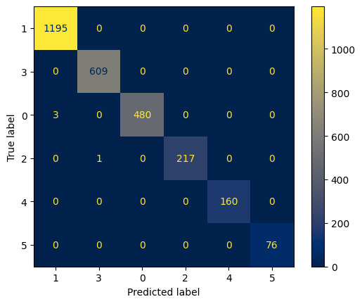

from sklearn.naive_bayes import GaussianNB  
nv = GaussianNB()  
nv=nv.fit(X_train, y_train)  
y_pred = nv.predict(X_test)  
clf = 'naive bayes classifier'  
model_eval(clf, y_test, y_pred)

naive bayes classifier  
ROC_AUC_Score: 0.998980962411688  
accuracy: 0.9981758482305728  
precision: 0.9980674862143978  
 precision recall f1-score support  
  
 0 1.00 0.99 1.00 483  
 1 1.00 1.00 1.00 1195  
 2 0.99 1.00 1.00 218  
 3 1.00 1.00 1.00 609  
 4 1.00 1.00 1.00 160  
 5 1.00 1.00 1.00 76  
  
 accuracy 1.00 2741  
 macro avg 1.00 1.00 1.00 2741  
weighted avg 1.00 1.00 1.00 2741

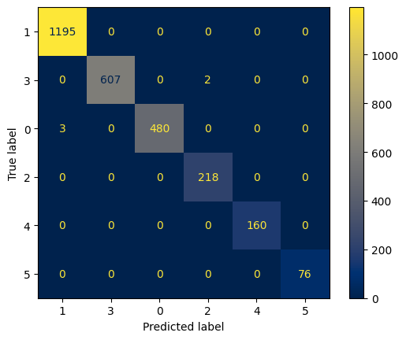

from sklearn.neural_network import MLPClassifier  
mlp= MLPClassifier(hidden_layer_sizes=(100,50), max_iter=1000)  
mlp=mlp.fit(X_train, y_train)  
y_pred = mlp.predict(X_test)  
clf = 'neural network classifier'  
model_eval(clf, y_test, y_pred)

neural network classifier  
ROC_AUC_Score: 0.9987294782914286  
accuracy: 0.9981758482305728  
precision: 0.9985444390481998  
 precision recall f1-score support  
  
 0 1.00 0.99 1.00 483  
 1 1.00 1.00 1.00 1195  
 2 1.00 1.00 1.00 218  
 3 1.00 1.00 1.00 609  
 4 1.00 1.00 1.00 160  
 5 1.00 1.00 1.00 76  
  
 accuracy 1.00 2741  
 macro avg 1.00 1.00 1.00 2741  
weighted avg 1.00 1.00 1.00 2741

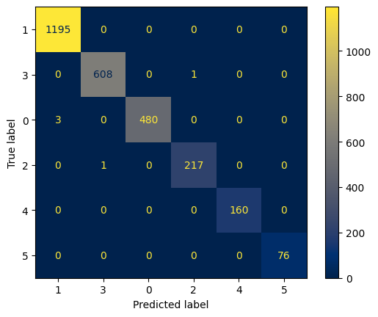

## Hồi quy

### Chạy trên 1 mô hình

from pdpbox import pdp  
import matplotlib.pyplot as plt  
y = df_model['Monthly Premium Auto']  
X = df_model.drop(columns=['Monthly Premium Auto','Cluster'])  
sc = StandardScaler()  
X= sc.fit_transform(X)  
X_train, X_test, y_train, y_test = train_test_split(X, y, test_size=0.15, random_state=0)  
xgb_r = XGBRegressor()  
xgb_r.fit(X_train,y_train)  
y_pred = xgb_r.predict(X_test)  
print(f'R Squared Score of XGBRegressor: {r2_score(y_pred, y_test)}')

R Squared Score of XGBRegressor: 0.9621639160680483

### Chạy trên 6 mô hình

from sklearn.metrics import mean_absolute_error, mean_squared_error, r2_score  
def xgb(a):  
 print(a)  
 y = df_model[df_model['Cluster']==a]['Monthly Premium Auto']  
 X = df_model[df_model['Cluster']==a].drop(columns=['Monthly Premium Auto','Cluster'])  
 # print(len(X.columns))  
 X_train, X_test, y_train, y_test = train_test_split(X, y, test_size=0.15, random_state=0)  
 xgb_r = XGBRegressor(n_estimators=100, max_depth=5, learning_rate=0.05)  
 xgb_r.fit(X_train,y_train)  
 y_pred = xgb_r.predict(X_test)  
 mae = mean_absolute_error(y_test, y_pred) # Mean Absolute Error  
 mse = mean_squared_error(y_test, y_pred) # Mean Squared Error  
 rmse = mean_squared_error(y_test, y_pred, squared=False) # Root Mean Squared Error  
 r2 = r2_score(y_test, y_pred) # Coefficient of Determination  
 print("Mean Absolute Error:", mae)  
 print("Mean Squared Error:", mse)  
 # print("Root Mean Squared Error:", rmse)  
 print('R Squared Score:',r2)

xgb(0)  
xgb(1)  
xgb(2)  
xgb(3)  
xgb(4)  
xgb(5)

0  
Mean Absolute Error: 4.7465874902133285  
Mean Squared Error: 31.270351280818556  
R Squared Score: 0.9547140210618511  
1  
Mean Absolute Error: 3.4489571021882113  
Mean Squared Error: 16.188214047728085  
R Squared Score: 0.4990399792857726  
2  
Mean Absolute Error: 6.008815107674434  
Mean Squared Error: 65.72198283879472  
R Squared Score: 0.9392987869930517  
3  
Mean Absolute Error: 5.764957685728331  
Mean Squared Error: 46.209037513465844  
R Squared Score: 0.23672672691939545  
4  
Mean Absolute Error: 4.887103201329023  
Mean Squared Error: 31.5665125858879  
R Squared Score: 0.010826548746861953  
5  
Mean Absolute Error: 15.287636421822214  
Mean Squared Error: 390.7687038286539  
R Squared Score: 0.8116726282489014

y = df_model[df_model['Cluster']==0]['Monthly Premium Auto']  
X = df_model[df_model['Cluster']==0].drop(columns=['Monthly Premium Auto','Cluster'])  
X_train, X_test, y_train, y_test = train_test_split(X, y, test_size=0.15, random_state=0)  
xgb_0 = XGBRegressor(n_estimators=100, max_depth=5, learning_rate=0.05)  
xgb_0.fit(X_train,y_train)

XGBRegressor(base_score=None, booster=None, callbacks=None,  
 colsample_bylevel=None, colsample_bynode=None,  
 colsample_bytree=None, early_stopping_rounds=None,  
 enable_categorical=False, eval_metric=None, feature_types=None,  
 gamma=None, gpu_id=None, grow_policy=None, importance_type=None,  
 interaction_constraints=None, learning_rate=0.05, max_bin=None,  
 max_cat_threshold=None, max_cat_to_onehot=None,  
 max_delta_step=None, max_depth=5, max_leaves=None,  
 min_child_weight=None, missing=nan, monotone_constraints=None,  
 n_estimators=100, n_jobs=None, num_parallel_tree=None,  
 predictor=None, random_state=None, ...)

y = df_model[df_model['Cluster']==1]['Monthly Premium Auto']  
X = df_model[df_model['Cluster']==1].drop(columns=['Monthly Premium Auto','Cluster'])  
X_train, X_test, y_train, y_test = train_test_split(X, y, test_size=0.15, random_state=0)  
xgb_1 = XGBRegressor(n_estimators=100, max_depth=5, learning_rate=0.05)  
xgb_1.fit(X_train,y_train)

XGBRegressor(base_score=None, booster=None, callbacks=None,  
 colsample_bylevel=None, colsample_bynode=None,  
 colsample_bytree=None, early_stopping_rounds=None,  
 enable_categorical=False, eval_metric=None, feature_types=None,  
 gamma=None, gpu_id=None, grow_policy=None, importance_type=None,  
 interaction_constraints=None, learning_rate=0.05, max_bin=None,  
 max_cat_threshold=None, max_cat_to_onehot=None,  
 max_delta_step=None, max_depth=5, max_leaves=None,  
 min_child_weight=None, missing=nan, monotone_constraints=None,  
 n_estimators=100, n_jobs=None, num_parallel_tree=None,  
 predictor=None, random_state=None, ...)

y = df_model[df_model['Cluster']==2]['Monthly Premium Auto']  
X = df_model[df_model['Cluster']==2].drop(columns=['Monthly Premium Auto','Cluster'])  
X_train, X_test, y_train, y_test = train_test_split(X, y, test_size=0.15, random_state=0)  
xgb_2 = XGBRegressor(n_estimators=100, max_depth=5, learning_rate=0.05)  
xgb_2.fit(X_train,y_train)

XGBRegressor(base_score=None, booster=None, callbacks=None,  
 colsample_bylevel=None, colsample_bynode=None,  
 colsample_bytree=None, early_stopping_rounds=None,  
 enable_categorical=False, eval_metric=None, feature_types=None,  
 gamma=None, gpu_id=None, grow_policy=None, importance_type=None,  
 interaction_constraints=None, learning_rate=0.05, max_bin=None,  
 max_cat_threshold=None, max_cat_to_onehot=None,  
 max_delta_step=None, max_depth=5, max_leaves=None,  
 min_child_weight=None, missing=nan, monotone_constraints=None,  
 n_estimators=100, n_jobs=None, num_parallel_tree=None,  
 predictor=None, random_state=None, ...)

y = df_model[df_model['Cluster']==3]['Monthly Premium Auto']  
X = df_model[df_model['Cluster']==3].drop(columns=['Monthly Premium Auto','Cluster'])  
X_train, X_test, y_train, y_test = train_test_split(X, y, test_size=0.15, random_state=0)  
xgb_3 = XGBRegressor(n_estimators=100, max_depth=5, learning_rate=0.05)  
xgb_3.fit(X_train,y_train)

XGBRegressor(base_score=None, booster=None, callbacks=None,  
 colsample_bylevel=None, colsample_bynode=None,  
 colsample_bytree=None, early_stopping_rounds=None,  
 enable_categorical=False, eval_metric=None, feature_types=None,  
 gamma=None, gpu_id=None, grow_policy=None, importance_type=None,  
 interaction_constraints=None, learning_rate=0.05, max_bin=None,  
 max_cat_threshold=None, max_cat_to_onehot=None,  
 max_delta_step=None, max_depth=5, max_leaves=None,  
 min_child_weight=None, missing=nan, monotone_constraints=None,  
 n_estimators=100, n_jobs=None, num_parallel_tree=None,  
 predictor=None, random_state=None, ...)

y = df_model[df_model['Cluster']==4]['Monthly Premium Auto']  
X = df_model[df_model['Cluster']==4].drop(columns=['Monthly Premium Auto','Cluster'])  
X_train, X_test, y_train, y_test = train_test_split(X, y, test_size=0.15, random_state=0)  
xgb_4 = XGBRegressor(n_estimators=100, max_depth=5, learning_rate=0.05)  
xgb_4.fit(X_train,y_train)

XGBRegressor(base_score=None, booster=None, callbacks=None,  
 colsample_bylevel=None, colsample_bynode=None,  
 colsample_bytree=None, early_stopping_rounds=None,  
 enable_categorical=False, eval_metric=None, feature_types=None,  
 gamma=None, gpu_id=None, grow_policy=None, importance_type=None,  
 interaction_constraints=None, learning_rate=0.05, max_bin=None,  
 max_cat_threshold=None, max_cat_to_onehot=None,  
 max_delta_step=None, max_depth=5, max_leaves=None,  
 min_child_weight=None, missing=nan, monotone_constraints=None,  
 n_estimators=100, n_jobs=None, num_parallel_tree=None,  
 predictor=None, random_state=None, ...)

y = df_model[df_model['Cluster']==5]['Monthly Premium Auto']  
X = df_model[df_model['Cluster']==5].drop(columns=['Monthly Premium Auto','Cluster'])  
X_train, X_test, y_train, y_test = train_test_split(X, y, test_size=0.15, random_state=0)  
xgb_5 = XGBRegressor(n_estimators=100, max_depth=5, learning_rate=0.05)  
xgb_5.fit(X_train,y_train)

XGBRegressor(base_score=None, booster=None, callbacks=None,  
 colsample_bylevel=None, colsample_bynode=None,  
 colsample_bytree=None, early_stopping_rounds=None,  
 enable_categorical=False, eval_metric=None, feature_types=None,  
 gamma=None, gpu_id=None, grow_policy=None, importance_type=None,  
 interaction_constraints=None, learning_rate=0.05, max_bin=None,  
 max_cat_threshold=None, max_cat_to_onehot=None,  
 max_delta_step=None, max_depth=5, max_leaves=None,  
 min_child_weight=None, missing=nan, monotone_constraints=None,  
 n_estimators=100, n_jobs=None, num_parallel_tree=None,  
 predictor=None, random_state=None, ...)

### Lưu mô hình

import pickle

pickle.dump(xgb_clf, open('classifier.pkl', 'wb'))  
pickle.dump(xgb_0, open('xgb0.pkl', 'wb'))  
pickle.dump(xgb_1, open('xgb1.pkl', 'wb'))  
pickle.dump(xgb_2, open('xgb2.pkl', 'wb'))  
pickle.dump(xgb_3, open('xgb3.pkl', 'wb'))  
pickle.dump(xgb_4, open('xgb4.pkl', 'wb'))  
pickle.dump(xgb_5, open('xgb5.pkl', 'wb'))

### Test dữ liệu mới

X = df_model.drop(columns=['Monthly Premium Auto','Cluster'])  
z=X.describe()  
export=z.to_excel (r'z.xlsx', index = None, header=True)  
z

Months Since Driving Age Months Since Last Claim   
count 9134.000000 9134.000000 9134.000000 \  
mean 177.558791 45.717320 15.097000   
std 149.118392 15.674646 10.073257   
min 0.000000 16.000000 0.000000   
25% 52.000000 33.000000 6.000000   
50% 141.000000 47.000000 14.000000   
75% 272.000000 59.000000 23.000000   
max 707.000000 75.000000 35.000000   
  
 Vehicle Class_Four-Door Car Vehicle Class_Luxury Car   
count 9134.000000 9134.000000 \  
mean 0.505912 0.017845   
std 0.499992 0.132397   
min 0.000000 0.000000   
25% 0.000000 0.000000   
50% 1.000000 0.000000   
75% 1.000000 0.000000   
max 1.000000 1.000000   
  
 Vehicle Class_Luxury SUV Vehicle Class_SUV Vehicle Class_Sports Car   
count 9134.000000 9134.000000 9134.000000 \  
mean 0.020145 0.196628 0.052989   
std 0.140502 0.397470 0.224023   
min 0.000000 0.000000 0.000000   
25% 0.000000 0.000000 0.000000   
50% 0.000000 0.000000 0.000000   
75% 0.000000 0.000000 0.000000   
max 1.000000 1.000000 1.000000   
  
 Vehicle Class_Two-Door Car Coverage_Basic ...   
count 9134.000000 9134.000000 ... \  
mean 0.206481 0.609591 ...   
std 0.404802 0.487869 ...   
min 0.000000 0.000000 ...   
25% 0.000000 0.000000 ...   
50% 0.000000 1.000000 ...   
75% 0.000000 1.000000 ...   
max 1.000000 1.000000 ...   
  
 EmploymentStatus_Disabled EmploymentStatus_Employed   
count 9134.00000 9134.000000 \  
mean 0.04434 0.623823   
std 0.20586 0.484452   
min 0.00000 0.000000   
25% 0.00000 0.000000   
50% 0.00000 1.000000   
75% 0.00000 1.000000   
max 1.00000 1.000000   
  
 EmploymentStatus_Medical Leave EmploymentStatus_Retired   
count 9134.000000 9134.000000 \  
mean 0.047296 0.030874   
std 0.212282 0.172985   
min 0.000000 0.000000   
25% 0.000000 0.000000   
50% 0.000000 0.000000   
75% 0.000000 0.000000   
max 1.000000 1.000000   
  
 EmploymentStatus_Unemployed State_Arizona State_California   
count 9134.000000 9134.000000 9134.000000 \  
mean 0.253668 0.186446 0.344865   
std 0.435133 0.389488 0.475350   
min 0.000000 0.000000 0.000000   
25% 0.000000 0.000000 0.000000   
50% 0.000000 0.000000 0.000000   
75% 1.000000 0.000000 1.000000   
max 1.000000 1.000000 1.000000   
  
 State_Nevada State_Oregon State_Washington   
count 9134.000000 9134.000000 9134.000000   
mean 0.096562 0.284760 0.087366   
std 0.295377 0.451325 0.282386   
min 0.000000 0.000000 0.000000   
25% 0.000000 0.000000 0.000000   
50% 0.000000 0.000000 0.000000   
75% 0.000000 1.000000 0.000000   
max 1.000000 1.000000 1.000000   
  
[8 rows x 28 columns]

def TEST(test,z):  
 listtest=[]  
 for k in X.columns:  
 l=k.split('_')  
 if len(l)==1:  
 x=(test[l[0]]-z[k][1])/z[k][2]  
 else:  
 if test[l[0]]==l[1]:  
 x=(1-z[k][1])/z[k][2]  
 else:  
 x=(0-z[k][1])/z[k][2]   
 listtest.append(x)  
 import numpy as np  
 user_input=np.array([listtest])  
 return user_input

def ketqua(test):  
 dl=TEST(test,z)  
 gr=xgb_clf.predict(dl)[0]  
 if gr==0:  
 gr='Basic B1'  
 y_pred = xgb_0.predict(TEST(test,z))[0]  
 elif gr==1:  
 gr='Basic B2'  
 y_pred = xgb_1.predict(TEST(test,z))[0]  
 elif gr==2:  
 gr='Extended E1'   
 y_pred = xgb_2.predict(TEST(test,z))[0]  
 elif gr==3:   
 gr='Extended E2'  
 y_pred = xgb_3.predict(TEST(test,z))[0]  
 elif gr==4:  
 gr='Premium P1'  
 y_pred = xgb_4.predict(TEST(test,z))[0]  
 elif gr==5:   
 gr='Premium P2'  
 y_pred = xgb_5.predict(TEST(test,z))[0]  
 y_p=round(y_pred)  
 print(f'Gói bảo hiểm phù hợp: {gr}')  
 print(f'Số tiền cần phải trả cho công ty là: {y_p}$')

test={'Months Since Driving':100,'Vehicle Class':'Two-Door Car','Age':24,'Coverage':'Extended','Marital Status':'Married',  
 'Location Code':'Suburban','EmploymentStatus':'Employed','Months Since Last Claim':48,'State':'Washington'}  
ketqua(test)

Gói bảo hiểm phù hợp: Extended E1  
Số tiền cần phải trả cho công ty là: 143$

class_model = pickle.load(open('classifier.pkl', 'rb'))  
dl=TEST(test,z)  
class_model.predict(dl)[0]  
reg_model = pickle.load(open('xgb2.pkl', 'rb'))  
reg_model.predict(dl)[0]

143.10268

clus

Cluster Count State   
0 B1 1542 [California, Arizona, Oregon, Washington, Nevada] \  
1 B2 4026 [Washington, Oregon, California, Nevada, Arizona]   
2 E1 769 [Washington, Nevada, Oregon, California, Arizona]   
3 E2 1973 [Arizona, Oregon, Washington, California, Nevada]   
4 P1 579 [Nevada, Arizona, California, Oregon, Washington]   
5 P2 245 [Oregon, Arizona, Washington, California, Nevada]   
  
 Vehicle Class Coverage   
0 [SUV, Sports Car, Luxury Car, Luxury SUV] [Basic] \  
1 [Two-Door Car, Four-Door Car, Sports Car, SUV] [Basic]   
2 [SUV, Luxury SUV, Sports Car, Luxury Car] [Extended]   
3 [Four-Door Car, Two-Door Car, SUV, Sports Car] [Extended]   
4 [Two-Door Car, Four-Door Car] [Premium]   
5 [SUV, Luxury SUV, Sports Car, Luxury Car] [Premium]   
  
 Marital Status Location Code   
0 [Married, Divorced, Single] [Suburban, Rural, Urban] \  
1 [Married, Single, Divorced] [Suburban, Rural, Urban]   
2 [Married, Divorced, Single] [Urban, Suburban, Rural]   
3 [Single, Married, Divorced] [Suburban, Urban, Rural]   
4 [Married, Single, Divorced] [Suburban, Urban, Rural]   
5 [Married, Single, Divorced] [Rural, Urban, Suburban]   
  
 EmploymentStatus Months Since Driving   
0 [Unemployed, Employed, Medical Leave, Disabled... 0.0 - 225.0 \  
1 [Employed, Medical Leave, Unemployed, Disabled... 0.0 - 706.0   
2 [Disabled, Employed, Unemployed, Medical Leave... 0.0 - 215.0   
3 [Unemployed, Employed, Disabled, Retired, Medi... 0.0 - 688.0   
4 [Employed, Unemployed, Disabled, Medical Leave... 0.0 - 707.0   
5 [Disabled, Employed, Unemployed, Retired, Medi... 0.0 - 533.0   
  
 Age Months Since Last Claim Monthly Premium Auto   
0 16.0 - 73.0 0.0 - 35.0 100.0 - 199.0   
1 36.0 - 75.0 0.0 - 35.0 61.0 - 119.0   
2 16.0 - 66.0 0.0 - 35.0 121.0 - 249.0   
3 37.0 - 75.0 0.0 - 35.0 76.0 - 139.0   
4 30.0 - 75.0 0.0 - 35.0 101.0 - 119.0   
5 16.0 - 74.0 0.0 - 35.0 140.0 - 298.0